Infosys Springboard Virtual Internship 6.0 Completion Report

# Team Details <Do not mention any personally identifiable information like email ID, institute details, mobile phone number etc.>

Batch Number: **NeuroFleetX AI Powered Urban Fleet and Traffic Intelligence**

**Start date :** 05-11-2025

**Names:**

1.Ganesh S

2.Narmadha L

3.Nitin Kamalesh

4.Pamala Dinesh Kumar

Internship Duration: 8 Weeks

# 1. Project Title

NeuroFleetX AI Powered Urban Fleet and Traffic Intelligence

**2. Project Objective**

NeuroFleetX is a smart fleet and traffic monitoring system that uses AI-assisted logic to support administrators, managers, and drivers in handling urban traffic efficiently. The system collects and processes vehicle and traffic-related information to determine congestion levels, identify risk-prone locations, and highlight unsafe road conditions. Instead of showing raw data, NeuroFleetX uses interactive dashboards, maps, and visual charts to make traffic information simple and easy to understand. The platform includes features such as live vehicle tracking, traffic alerts, risk analysis, and route guidance to enhance safety and operational efficiency. Role-based access is implemented so that Admins, Managers, and Drivers can access only the features relevant to their responsibilities. Although the current version uses basic AI logic, the system is built in a way that allows future integration of advanced machine learning models for smarter traffic prediction and automated decision-making. Overall, NeuroFleetX helps improve traffic visibility, minimizes manual effort, and serves as a scalable base for future intelligent transportation solutions.

# 3.Project description in detail

NeuroFleetX is an intelligent fleet and traffic management platform that uses AI-assisted logic to handle the increasing complexity of urban transportation systems. With the rapid growth of city traffic and vehicle numbers, traditional methods are no longer sufficient to manage traffic flow and road safety effectively. NeuroFleetX addresses this challenge by offering a centralized digital solution to monitor vehicles, traffic conditions, and risk-prone areas in a structured and visual way.

The system is developed as a **full-stack web application**, where the frontend focuses on user-friendly dashboards, charts, and map views, while the backend manages data handling, storage, security, and business logic. Access to the system is role-based, allowing Admins, Managers, and Drivers to interact with features specific to their responsibilities.

The **Admin module** provides complete system control. Admin users can manage vehicles, drivers, and users, monitor city-wide traffic conditions, analyze risk zones, handle alerts, and view traffic insights through dashboards and visual reports. This module offers a high-level overview of fleet activity and traffic status across the city.

The **Manager module** supports daily traffic and fleet operations. Managers are responsible for updating traffic information for various locations, monitoring congestion levels, identifying risk zones, tracking fleet status, and responding to alerts. This role plays a key part in ensuring smooth and efficient traffic operations.

The **Driver module** is designed for users who are actively traveling on the road. Drivers can create and track trips, view recommended routes, perform GPS-based location check-ins, monitor vehicle health, and receive traffic or safety-related alerts. These features help drivers make better decisions and avoid congested or risky routes.

NeuroFleetX also includes **AI-assisted functionalities** such as traffic analysis, congestion classification, risk zone detection, route suggestions, and alert generation. At the current stage, these features are implemented using basic AI logic and rule-based analysis. The frontend represents this information visually using charts, maps, and color-coded indicators to simplify complex traffic data.

Although the present version relies on manually entered or sample data, the system architecture is designed to support future integration of advanced AI and machine learning models. In upcoming versions, traffic data can be automatically collected and analyzed in real time to predict congestion, identify accidents, and recommend optimal routes with minimal human intervention.

Overall, NeuroFleetX serves as a scalable and flexible foundation for developing intelligent traffic and fleet management solutions. It enhances traffic awareness, improves road safety, reduces manual effort, and supports smarter decision-making in modern urban transportation environments.

**4. Timeline Overview**

|  |  |  |
| --- | --- | --- |
| Week | Activities Planned | Activities Completed |
| Week 1 | Requirement gathering, problem analysis, and project planning | Requirements finalized, project idea approved, team roles assigned |
| Week 2 | Project scope definition and technology selection | Scope documented, tech stack finalized (React, Spring Boot, MySQL, JWT) |
| Week 3 | Database design and backend setup | Database schema created and tested with sample datasets |
| Week 4 | Authentication and role-based access implementation | Login & registration pages completed, JWT authentication implemented |
| Week 5 | |  | | --- | |  |  |  | | --- | | Admin module development | | Admin dashboard, user management, driver management, and vehicle management completed. |
| Week 6 | Manager and Driver module UI development | Manager dashboard, traffic management UI, driver dashboard, trip management UI completed |
| Week 7 | Alerts module and frontend integration | Alerts page implemented, create/resolve alerts, real-time refresh added |
| Week 8 | |  | | --- | |  | | AI Analytics frontend and system integration | | | AI Analytics UI completed, charts and risk visualization added, documentation finalized |

# 5a. Key Milestones

|  |  |  |
| --- | --- | --- |
| Milestone | Description | Date Achieved |
| Project Kickoff | Project kickoff defined objectives, scope, and roles. | 10 – Nov - 2025 |
| Prototype/First Draft | Developed the prototype for NeuroFleetX AI Powered Urban Fleet and Traffic Intelligence | 24- Nov - 2025 |
| Mid-Term Review | Completed mid-term review to assess progress and refine project approach. | 02- Dec - 2025 |
| Final Submission | Submitted the completed Budgetwise project with full functionality and documentation. | 17- Dec - 2025 |
| Presentation | Prepared and delivered the project presentation showcasing features and outcomes. | 3- jan - 2025 |

# 5b. Project execution details

* **Requirement Understanding**  
  Analyzed project needs, studied urban traffic challenges, identified system goals, and finalized the overall project scope.
* **Technology Stack Finalization**  
  Chose **React** for building the user interface, **Spring Boot** for backend services, **MySQL** for data storage, and **JWT** for secure authentication. **OpenStreetMap** was used for map-based features.
* **System Architecture & Design**  
  Created database models, designed API communication flow, defined role-based access, and prepared initial UI layouts for Admin, Manager, and Driver modules.
* **Authentication & Role Management**  
  Developed secure login and registration functionality using JWT and implemented role-based access control for different users.
* **Main Module Development**  
  Implemented core Admin functionalities including dashboard, vehicle management, user management, and driver management.
* **Traffic & Fleet Operations**  
  Added features to handle traffic-related data, monitor fleet status, and manage basic trip-related information.
* **Alerts Feature Development**  
  Built the alerts module to create, display, classify severity levels, and resolve alerts with automatic page updates.
* **AI Analytics – Frontend Implementation**  
  Designed and implemented the AI Analytics user interface using charts, colors, and visual indicators to represent traffic congestion and risk zones.
* **AI Tools (Basic Implementation)**  
  Added route explorer and traffic analysis features using simple AI-assisted and rule-based logic.
* **Testing & System Integration**  
  Verified frontend and backend communication, tested APIs, and fixed functional and UI-related issues.
* **Documentation & Final Presentation**  
  Completed project documentation, prepared presentation slides, explained code flow, and delivered the final project demonstration.

# 6. Snapshots / Screenshots

**Step 1 : Go to Github and clone the Repository in your system then open in VS Code to do the execution , here is the github repo link :** https://github.com/NarmadhaLoganathan/NeuroFleetX-TeamB

**Step 2 : Folders,Terminal**

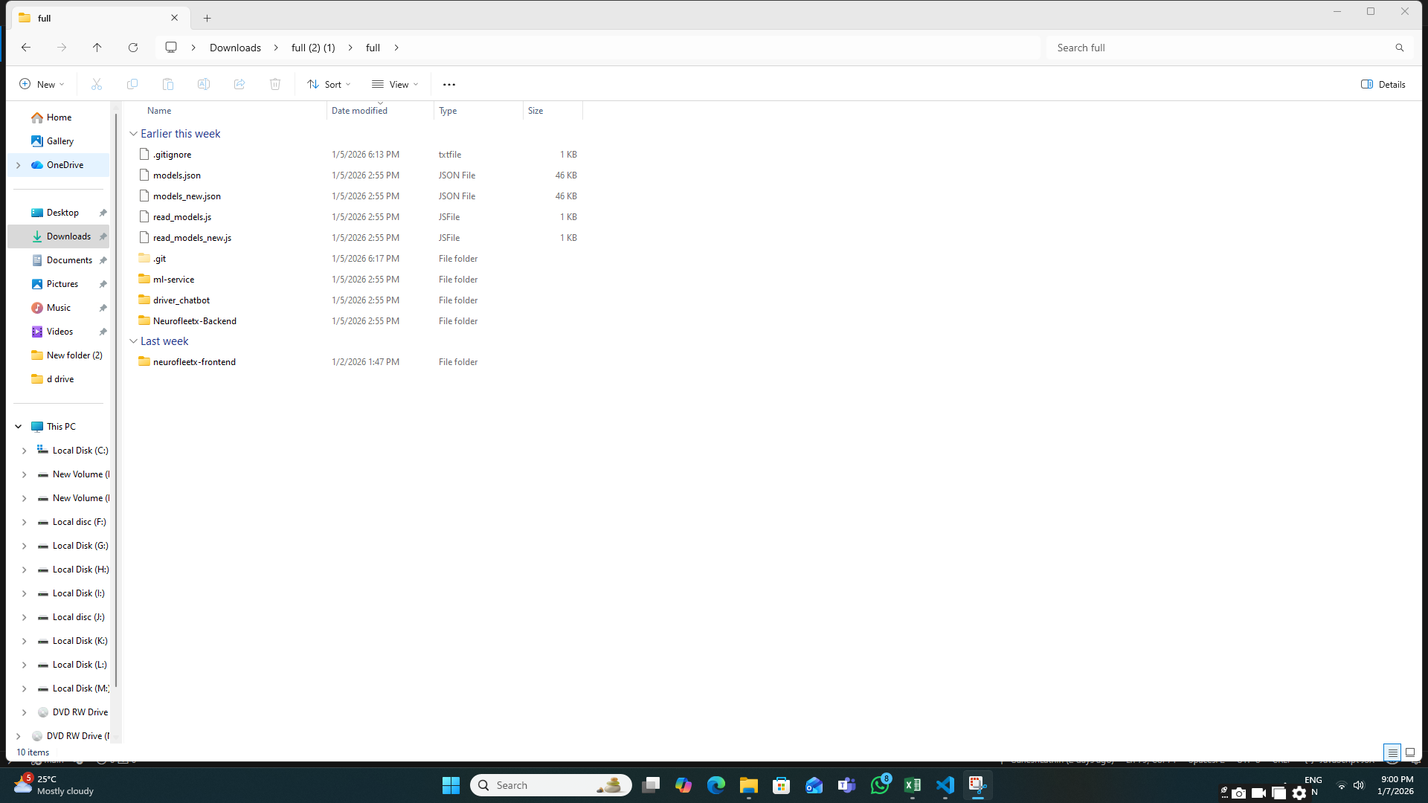

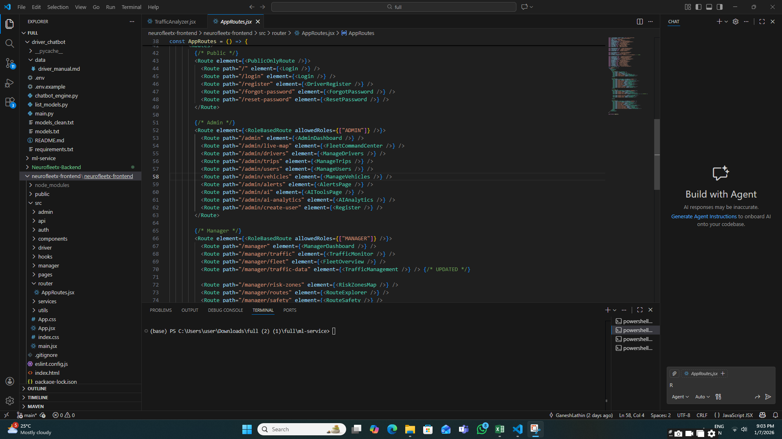

**Step 3 : Login / Signup Navigation**

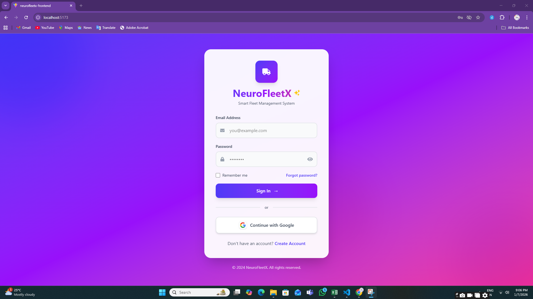 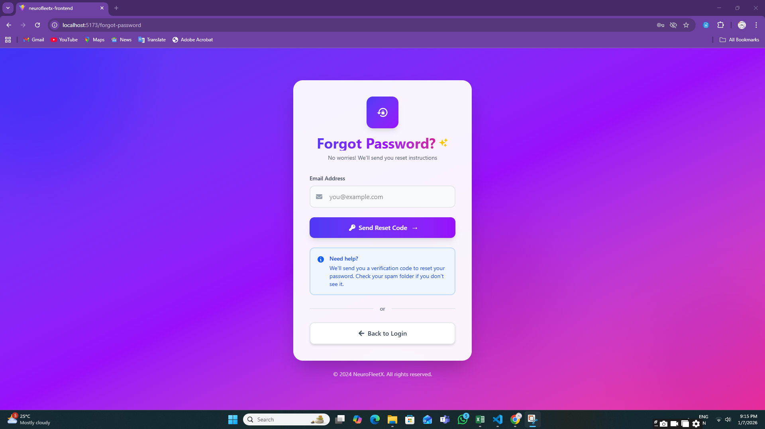

**Step 4: Registration Page**

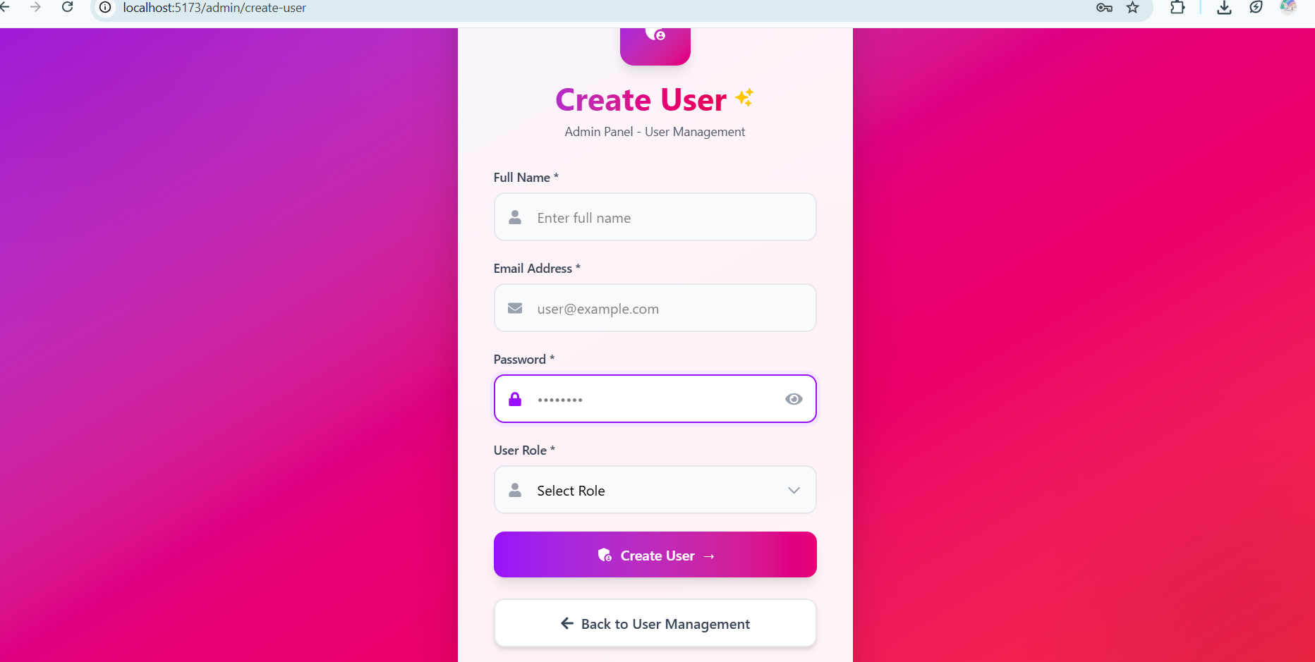

**Step 5: Role-Based Redirection**

After successful login, users are automatically redirected to their respective dashboards:

* **Admin Dashboard**

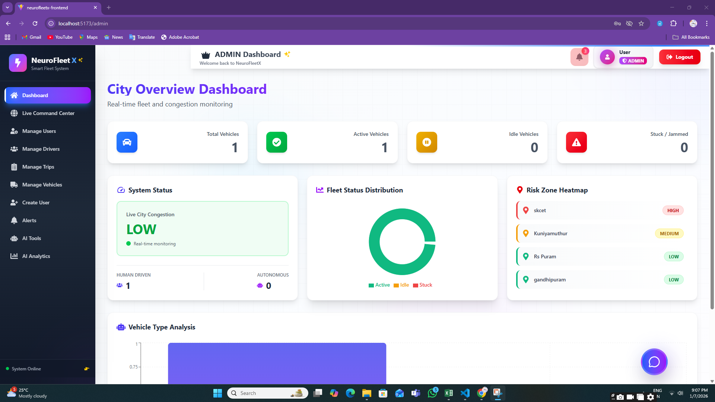

* **Manager Dashboard**

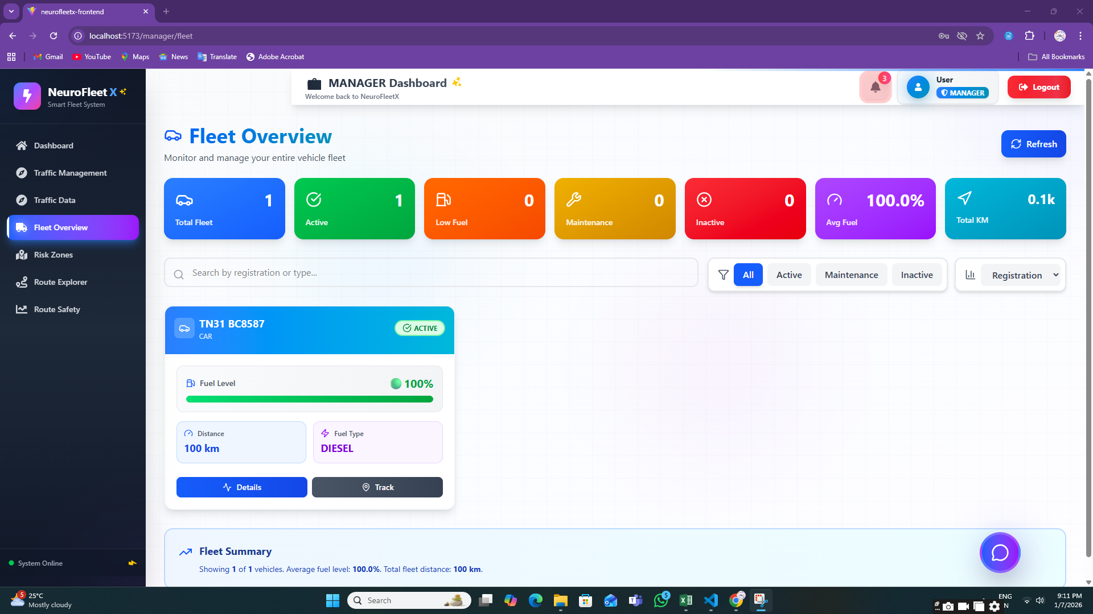

* **Driver Dashboard**

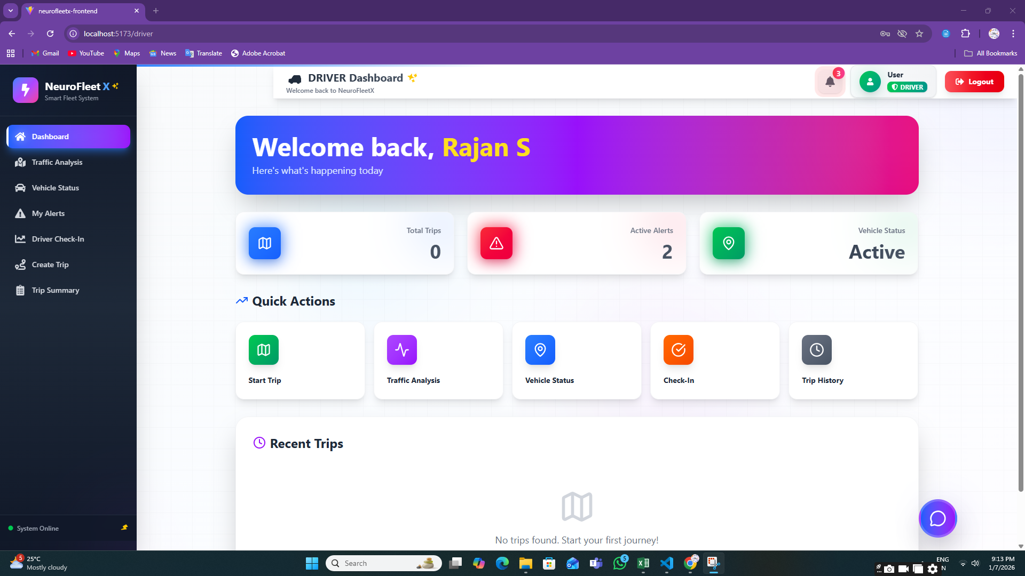

This confirms role-based access control.

**Step 6: ADMIN MODULE**

**6.1:** **Vehicle Management Page**

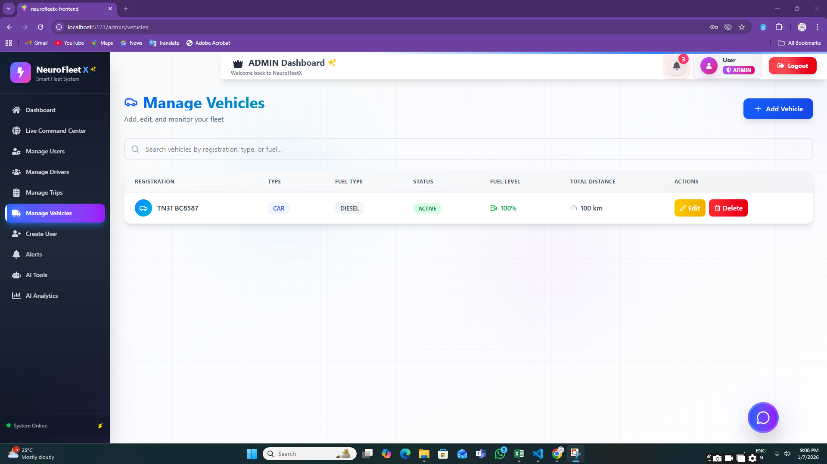

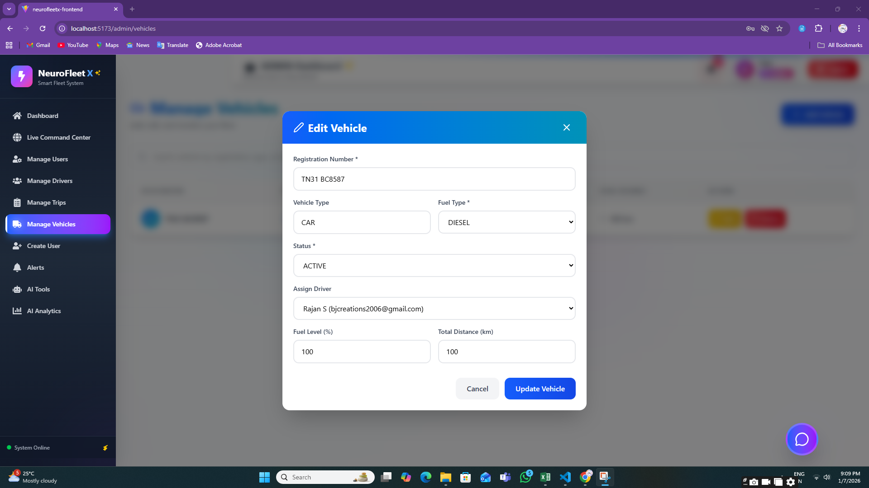

**6.2:** **User Management Page**

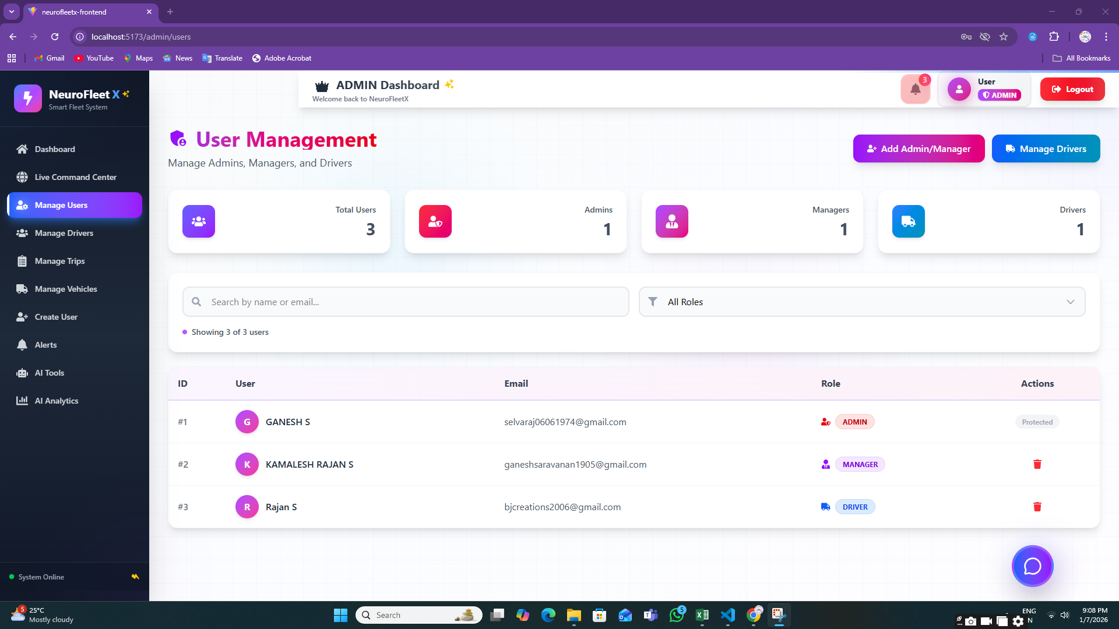

**6.3:** **Driver Management Page**

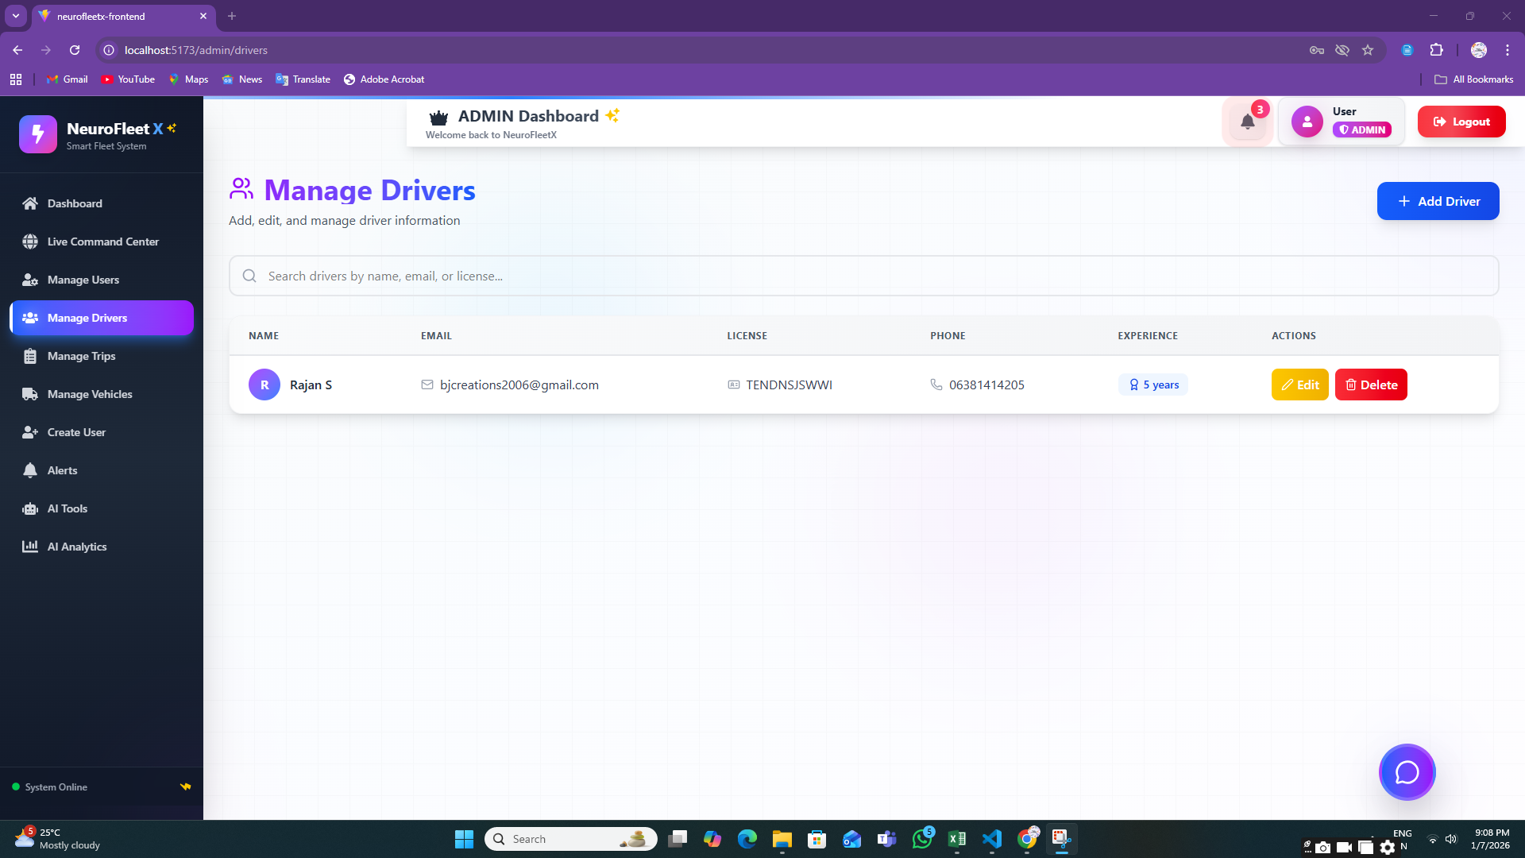

**6.4:** **Alerts Page (Admin View)**

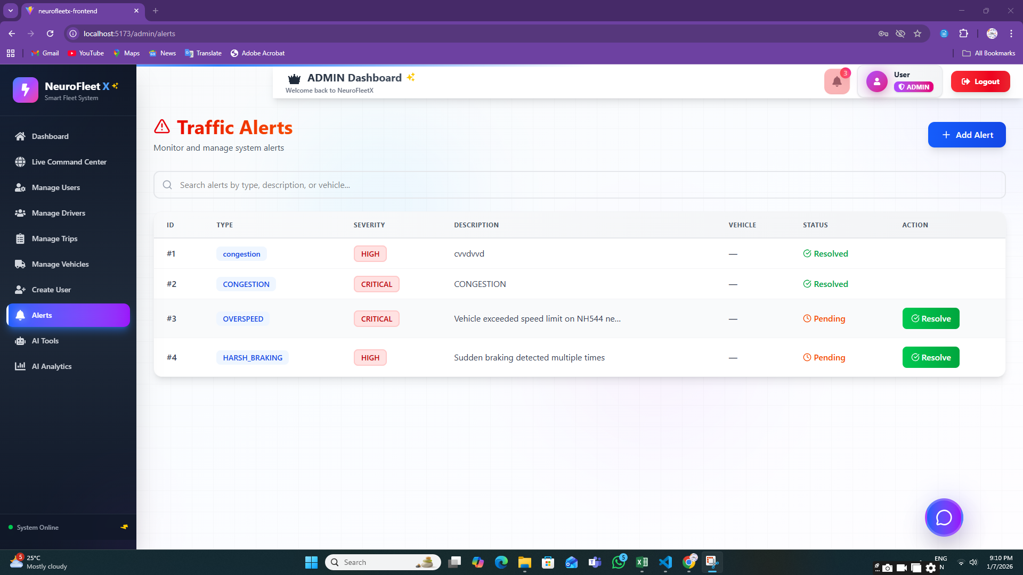

**6.5:** **AI Analytics Page**

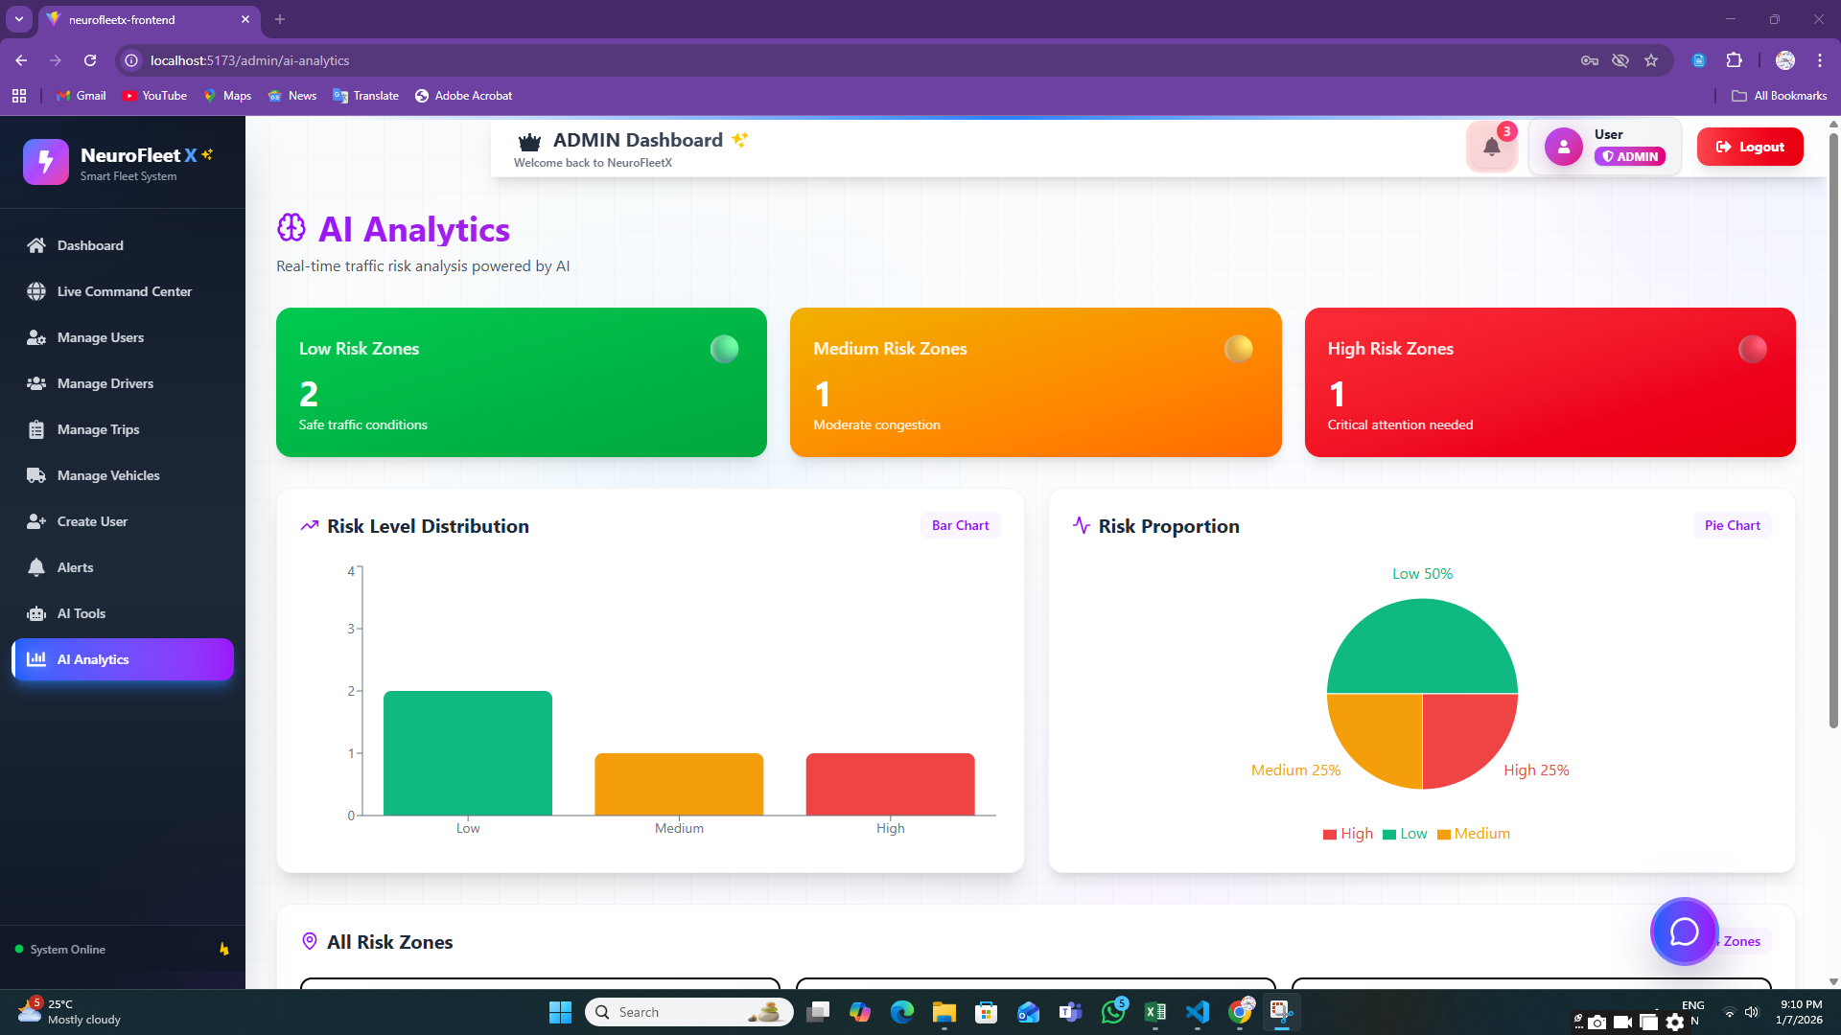

**6.6:AI Tools**

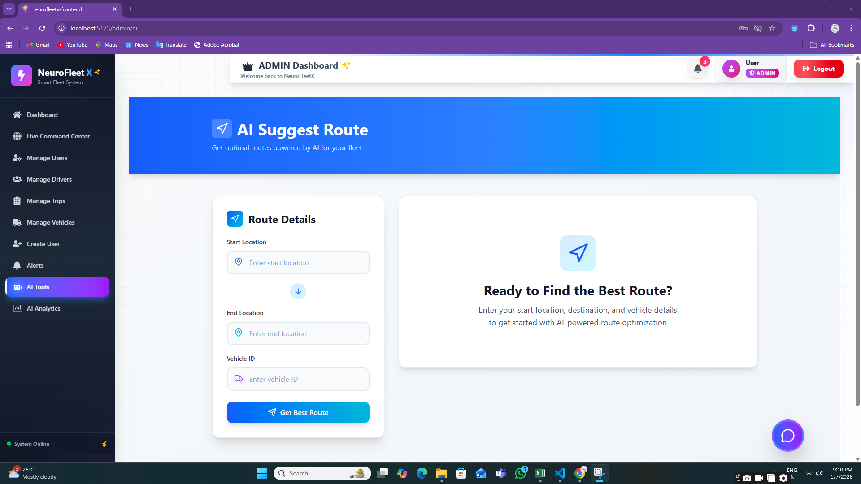

**6.7:Manage Trips**

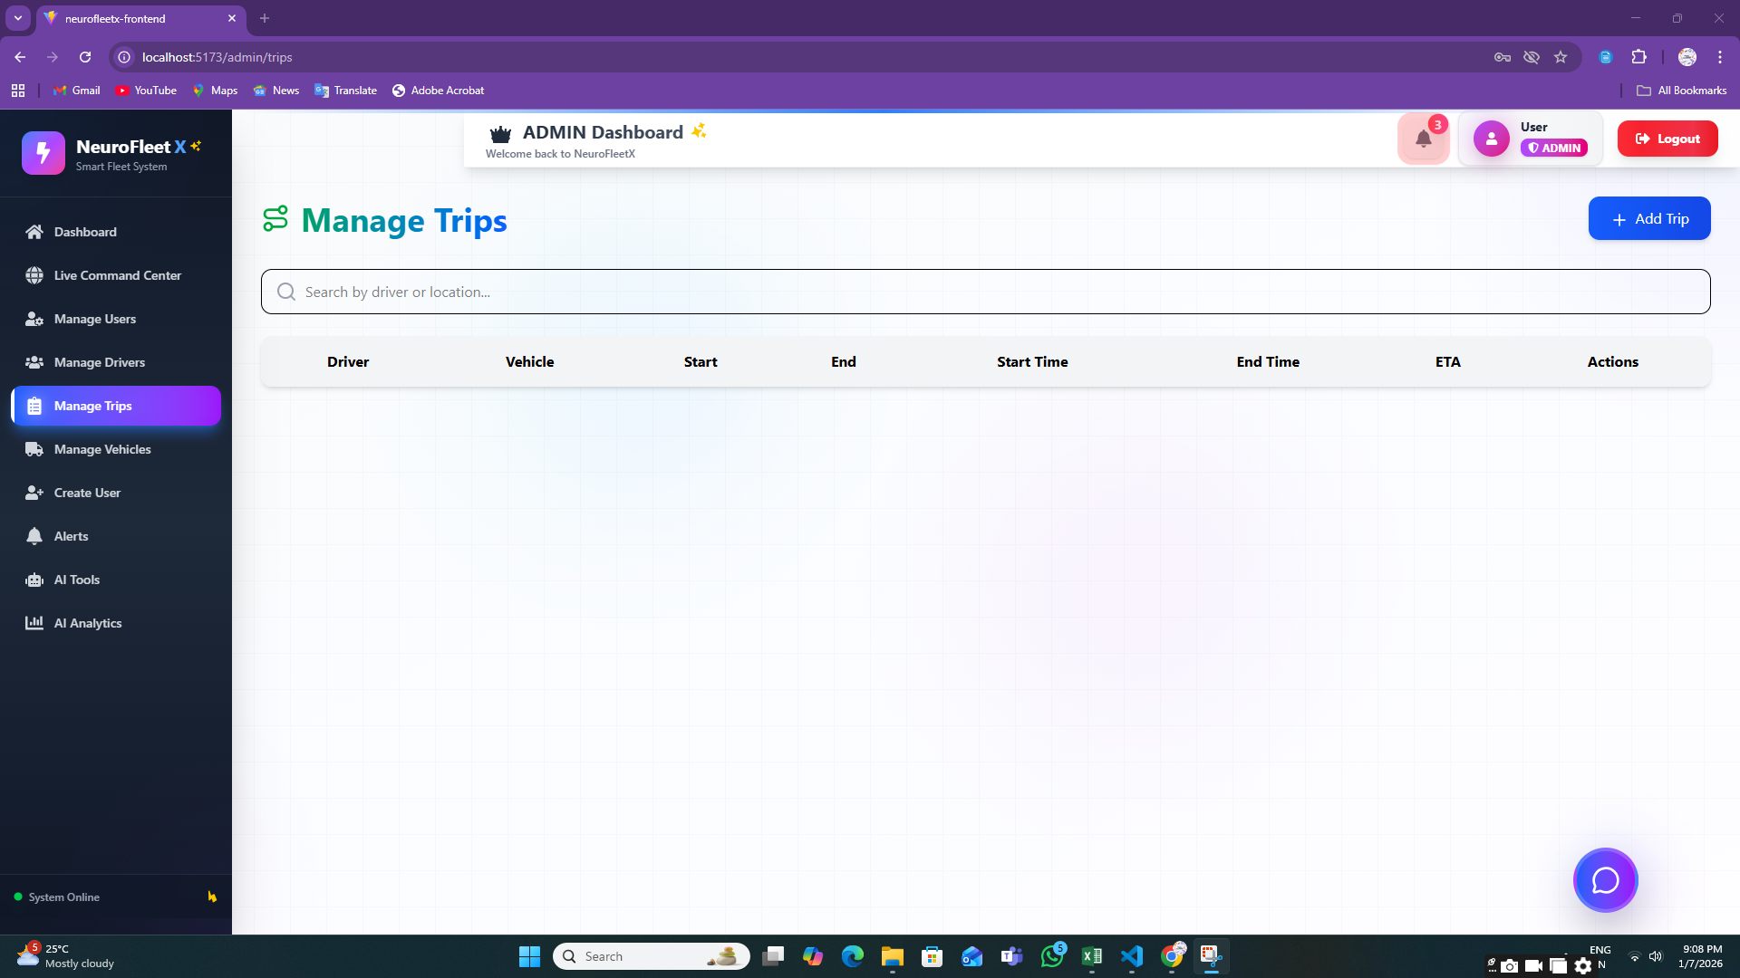

**Step 7:** **MANAGER MODULE**

**7.1:Traffic Management Page**

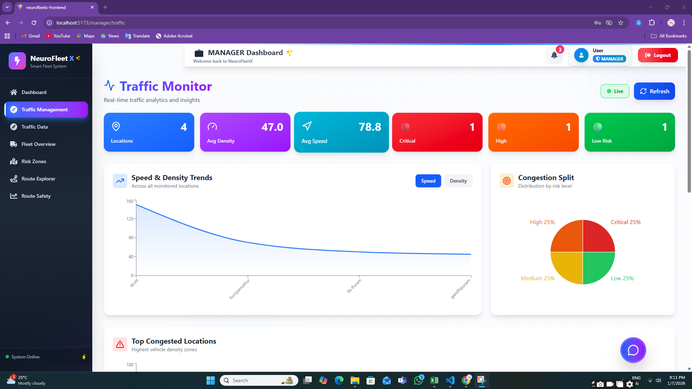

**7.2:** **Risk Zone Map**

**7.3:Traffic Data**

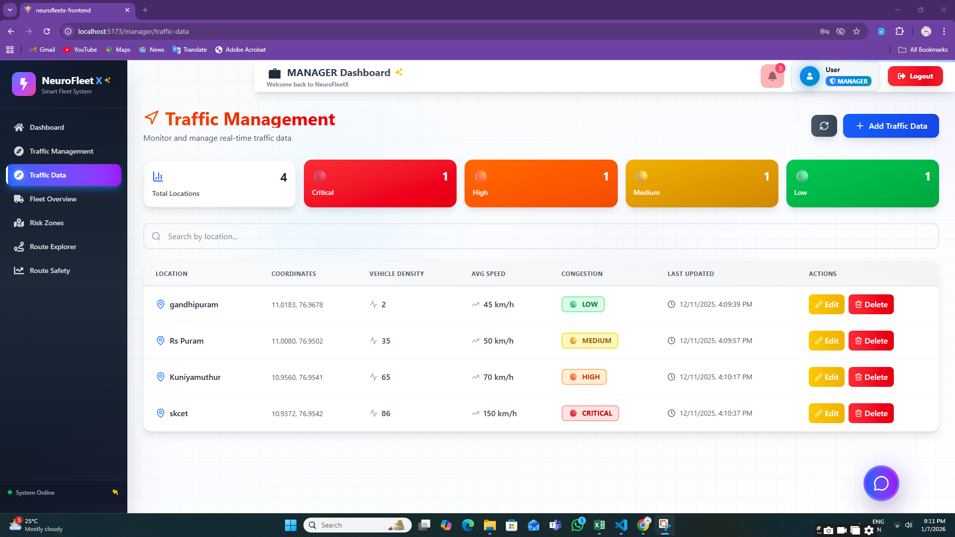

**7.4:Route Explorer**

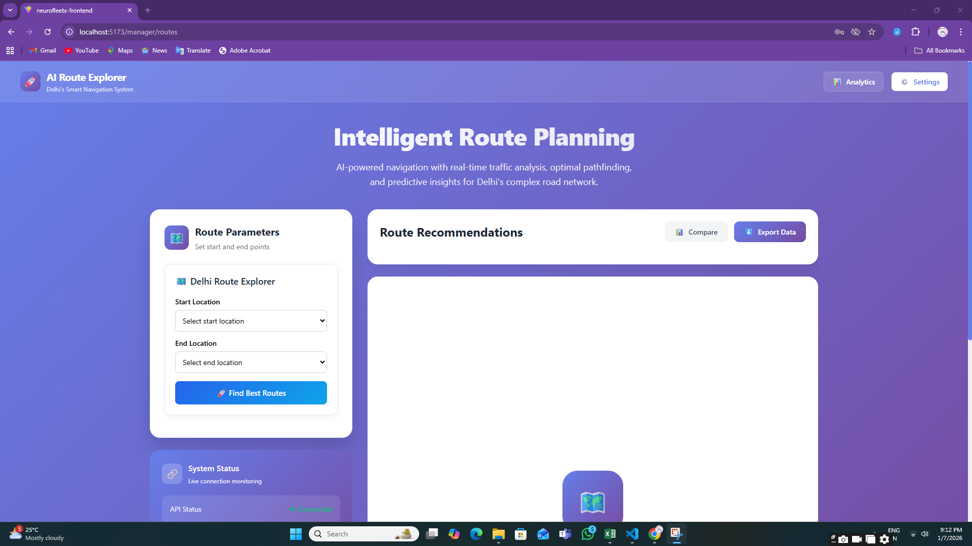

**7.5:Route Safety Analysis**

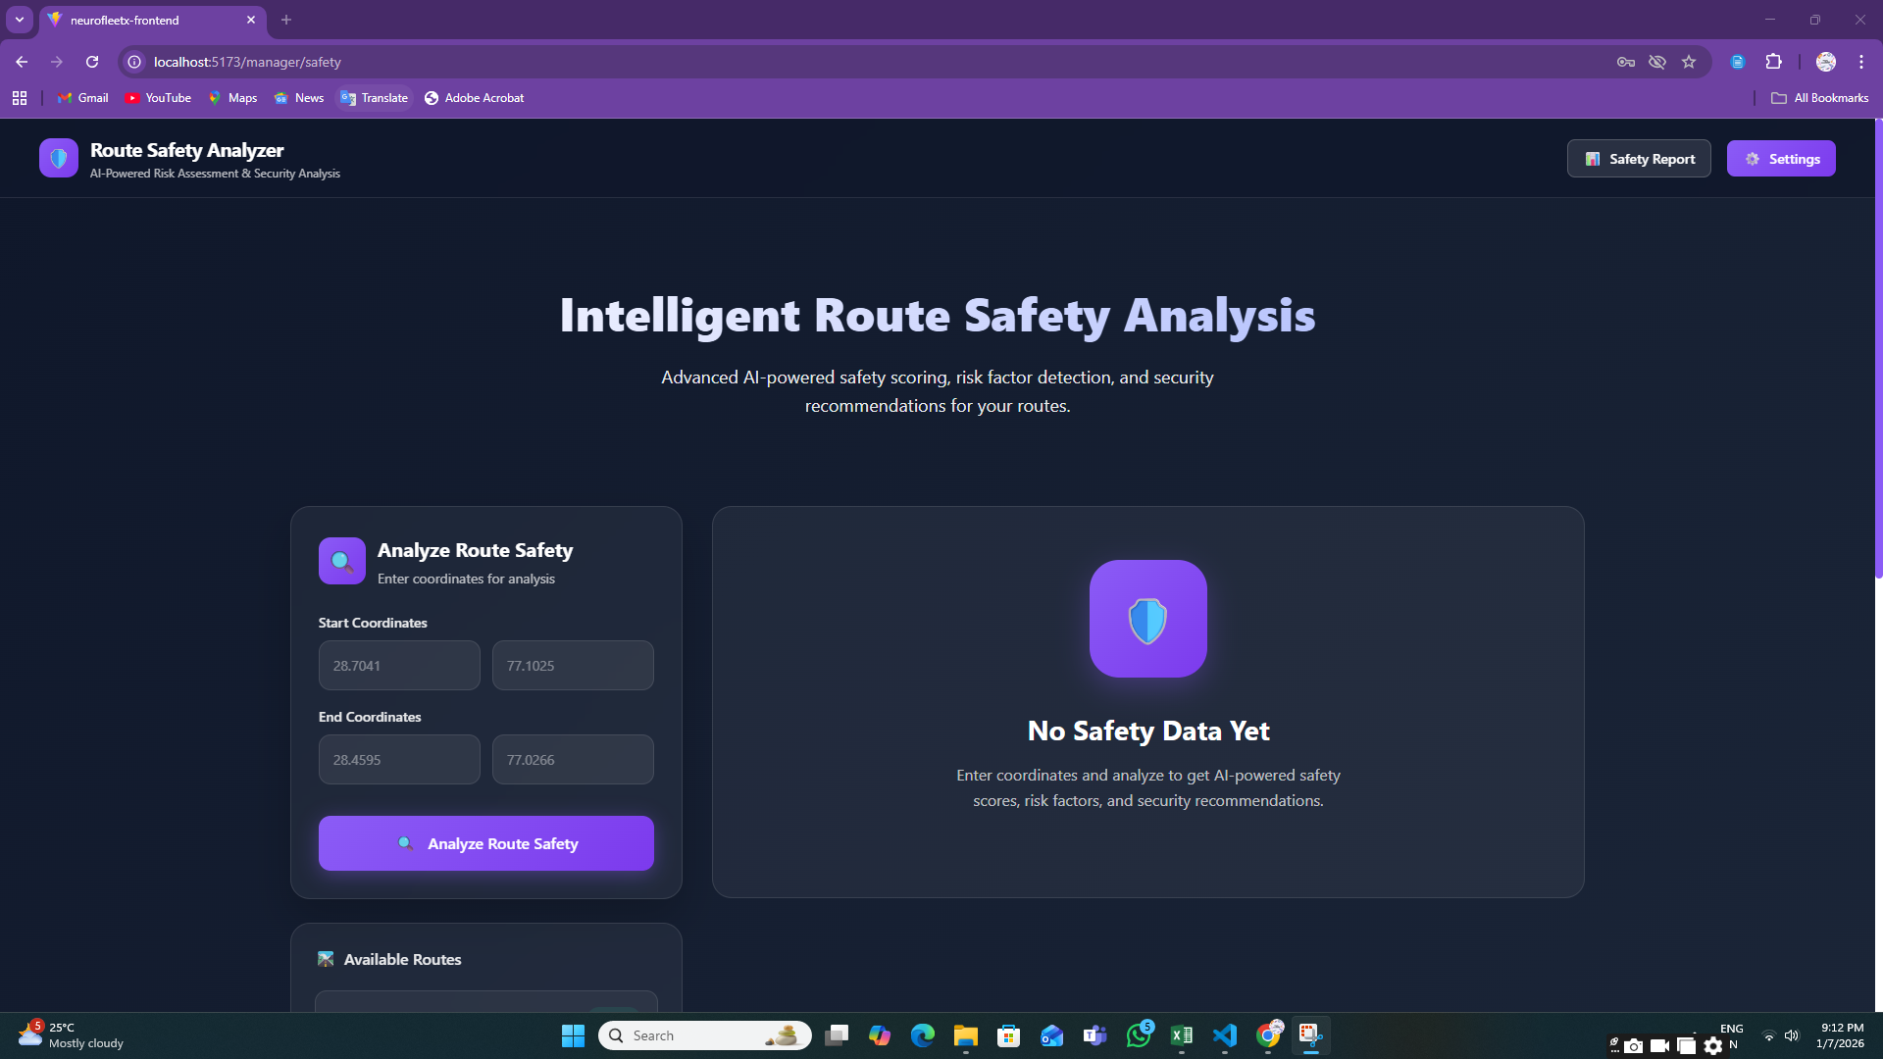

**Step 8:** **DRIVER MODULE**

**8.1:** **Create Trip Page**

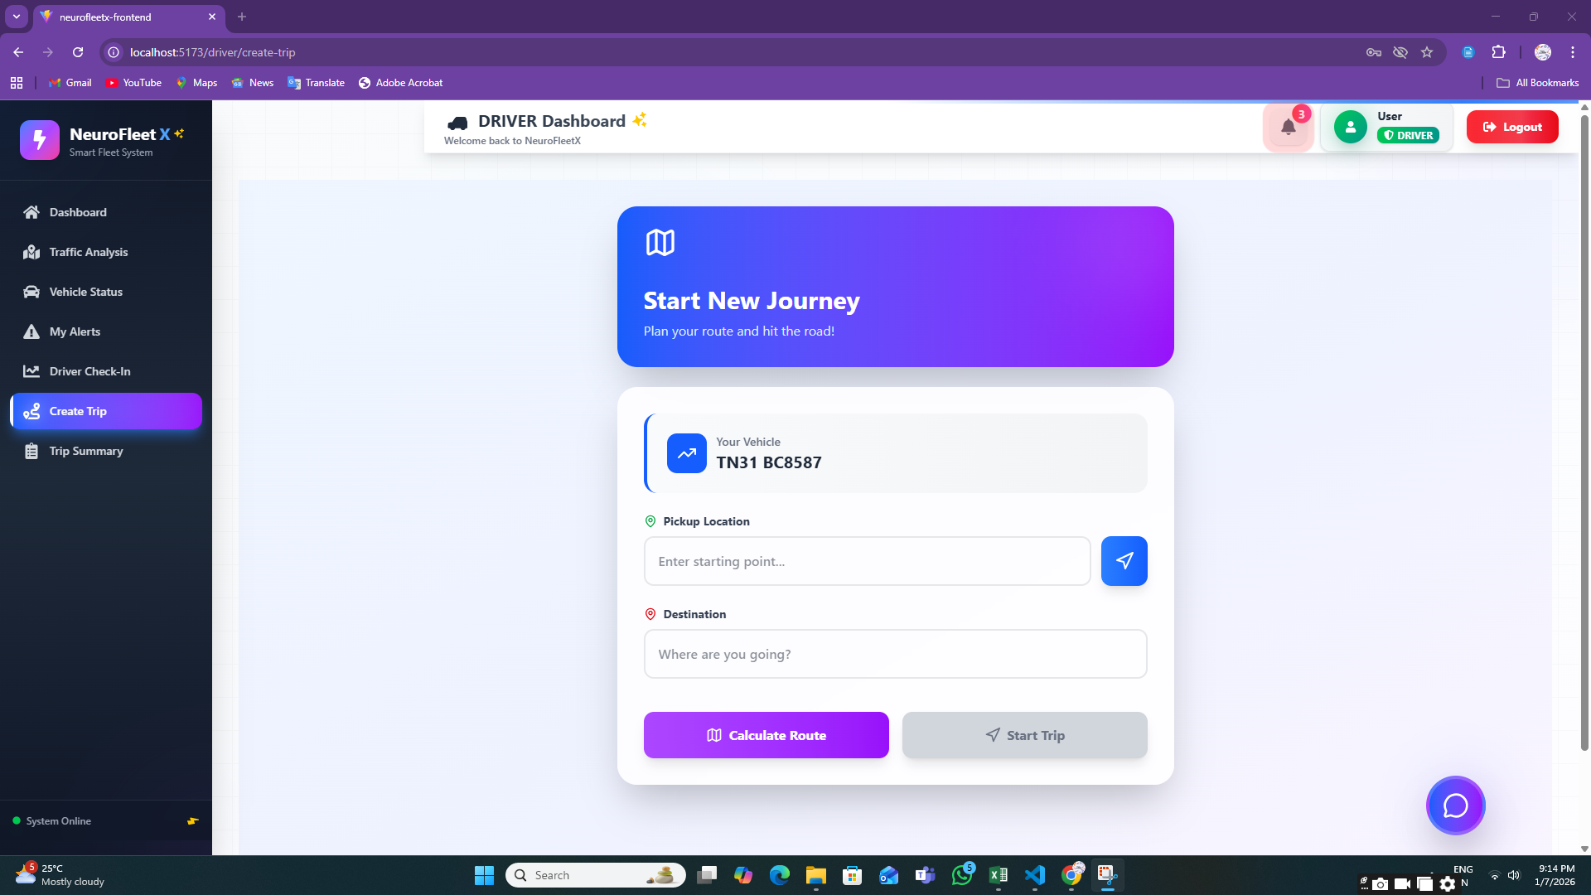

**8.2:** **Route Explorer**

**8.3:** **Traffic Analysis Page**

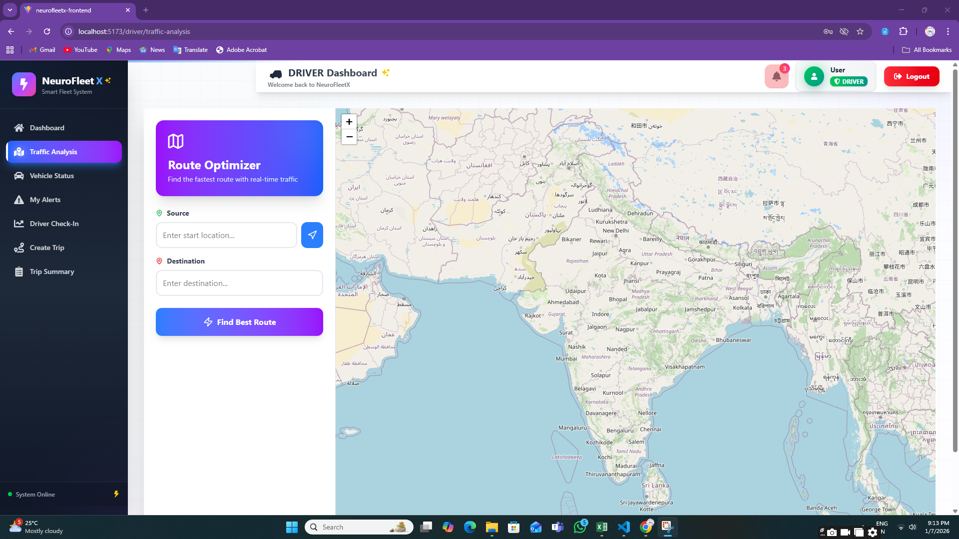

**8.4:** **Vehicle Status Page**

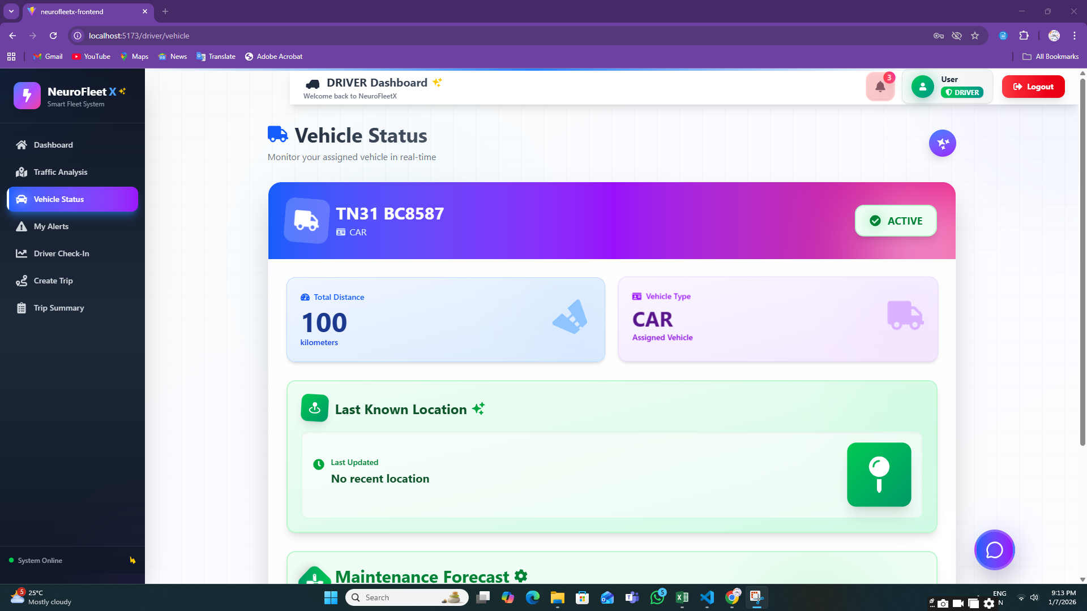

**8.5:** **My Alerts Page**

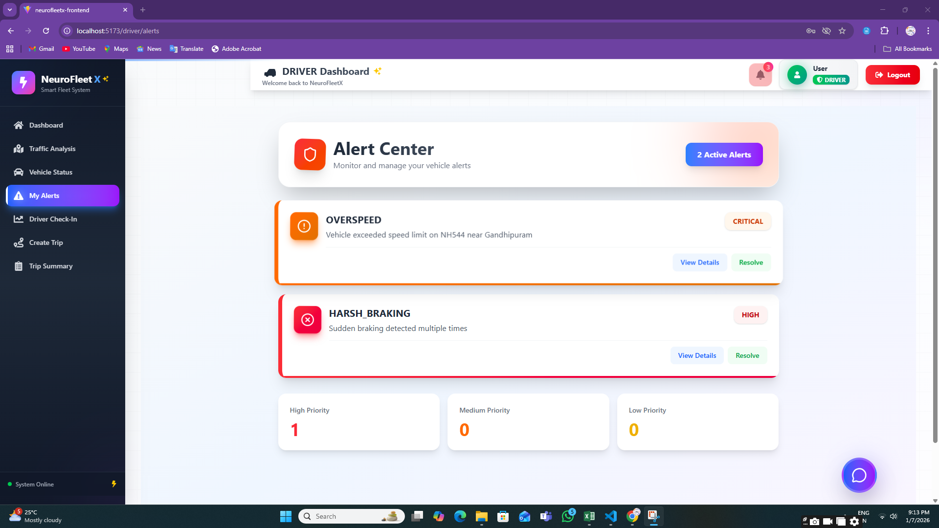

**8.6:** **Driver Check-In**

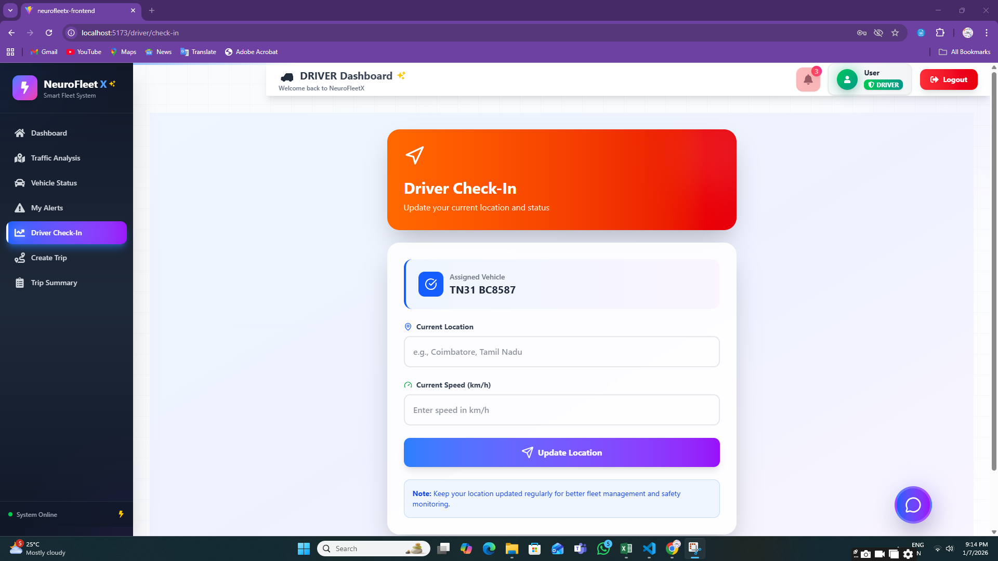

**8.7:** **Trip Summary Page**

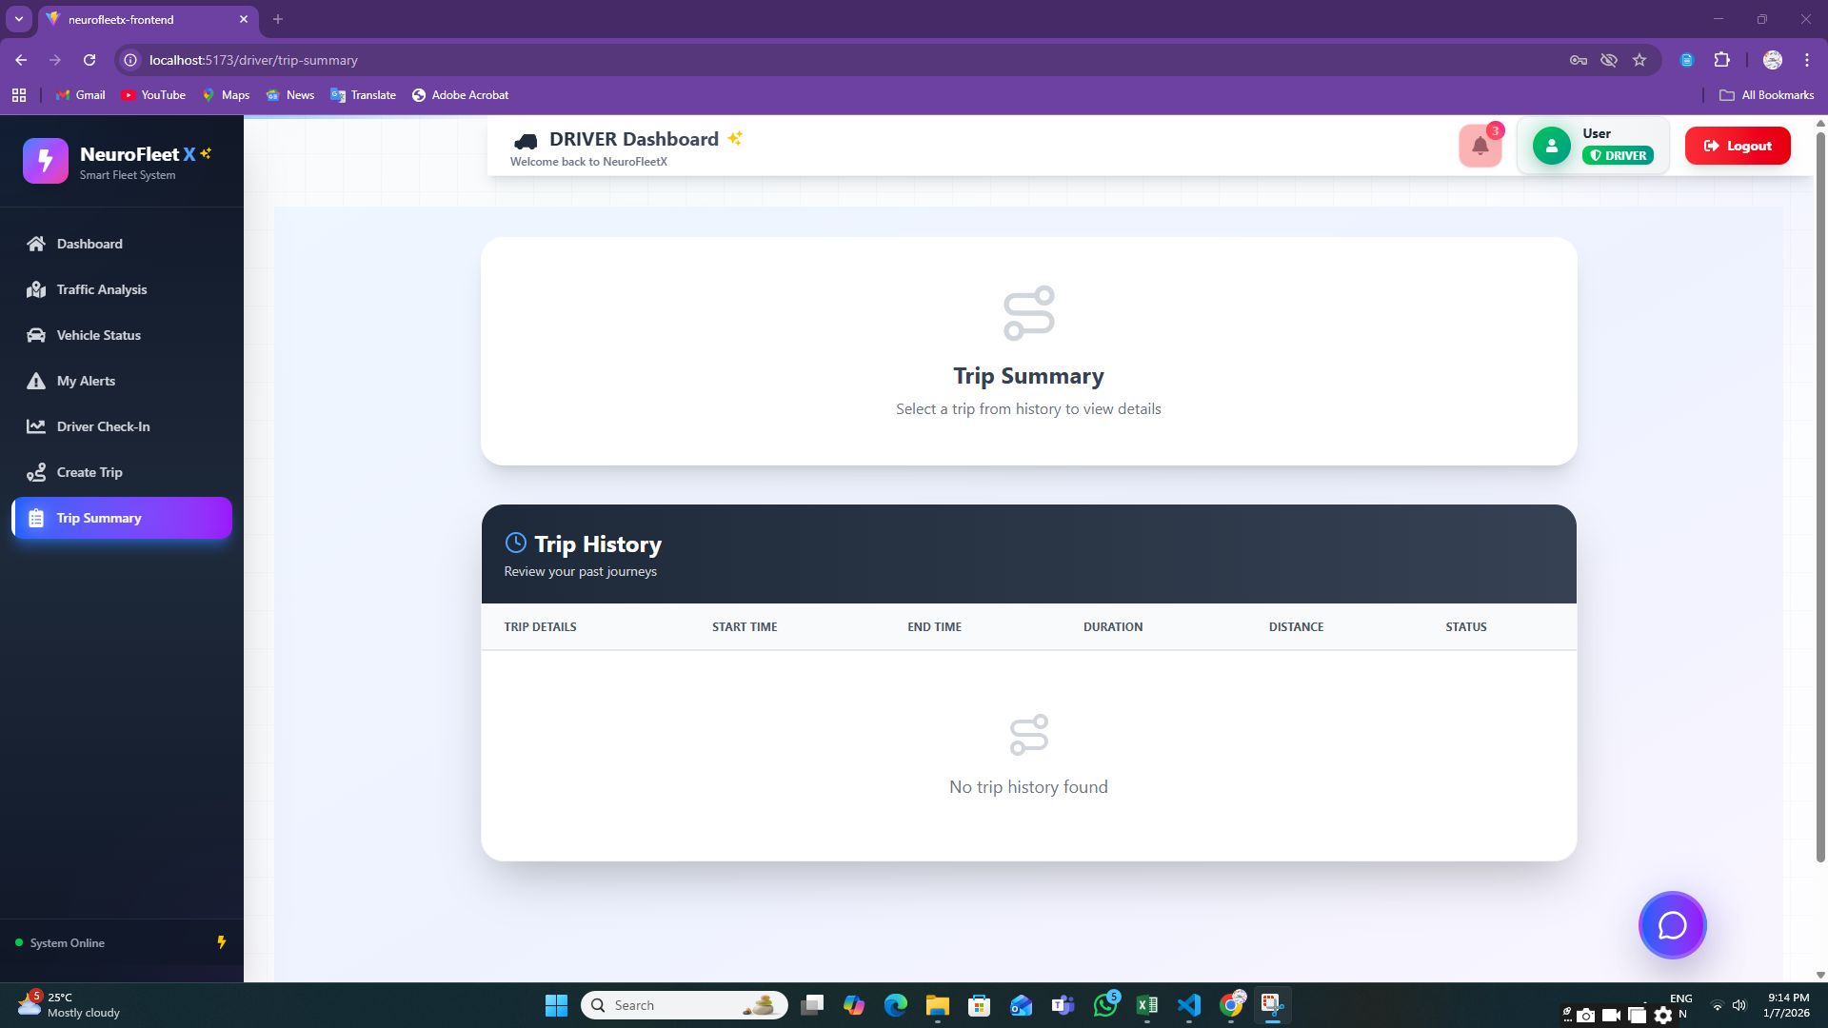

**7. Challenges Faced**

* Lack of Live Traffic Data  
  Real-time traffic data was not easily available, so sample data and manually entered values were used during development and testing.
* Understanding AI Concepts  
  Learning basic AI ideas and deciding how to apply them to traffic analysis and risk detection was challenging at the initial stage.
* System Resource Constraints  
  Limited laptop performance and memory issues affected backend processing and AI-related experimentation.
* Complexity in AI Integration  
  Integrating AI-assisted logic with backend APIs and frontend dashboards required repeated testing and debugging.
* Map and Location Handling  
  Working with maps, coordinates, and location-based services needed careful implementation to avoid incorrect data or errors.
* Role-Based Security Management  
  Implementing secure access for Admin, Manager, and Driver roles using JWT required extra attention to authorization logic.
* Managing Time Effectively  
  Balancing learning new concepts, development work, testing, documentation, and presentations within the given timeframe was challenging.

**8. Learnings & Skills Acquired**

* Basic AI Knowledge  
  Gained understanding of how AI can support traffic congestion analysis, risk identification, and route guidance.
* Full-Stack Development Experience  
  Improved skills in React for frontend, Spring Boot for backend, and MySQL for database management.
* Authentication & Security  
  Learned to implement secure login systems using JWT and role-based access control.
* Dashboard & Data Visualization  
  Developed the ability to present traffic and fleet data using charts, color indicators, and maps.
* API Development Skills  
  Gained experience in creating REST APIs and connecting frontend interfaces with backend services.
* Debugging & Problem Solving  
  Improved ability to identify issues, debug errors, and enhance system stability.
* Teamwork & Collaboration  
  Strengthened communication and coordination skills by working together on shared tasks and milestones.

**9. Team Testimonials**

Team Member 1:  
“This project helped me understand how AI ideas can be applied to real traffic-related problems and improved my backend development skills.”

Team Member 2:  
“I learned how to build dashboards and visually represent traffic data in a clear and user-friendly way.”

Team Member 3:  
“Working on NeuroFleetX improved my understanding of authentication, role-based access, and overall system integration.”

Team Member 4:  
“This project increased my confidence in full-stack development and gave me insight into smart city solutions.”

**10. Conclusion**

The NeuroFleetX project successfully showcases a smart, role-based fleet and traffic management system.  
It includes dashboards, alerts, traffic analytics, and AI-assisted features that help improve traffic awareness and safety.  
Although advanced AI models are not fully integrated at this stage, the system architecture is designed to support future AI and machine learning enhancements.  
Overall, this project provided valuable technical knowledge, practical development experience, and a strong understanding of intelligent transportation systems.

**11. Acknowledgements**

I would like to express my sincere gratitude to our institution and organization for providing the opportunity to work on the NeuroFleetX project.  
I am especially thankful to our mentor for their continuous guidance, encouragement, and valuable feedback throughout the project.  
I also thank my team members for their cooperation, teamwork, and support, which played a key role in the successful completion of this project.  
Finally, I appreciate everyone who contributed directly or indirectly to our learning and project development**.**